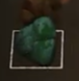
When you are in the world as a player, walking around and hovering over something that is interactable by the tool you are holding (for example, if you are holding the wrench and hover over a resource), it should show an extra graphic around that tile slot to indicate that is the action you can perform on that tile.

For now, we don't need the actual sprite or sprite animation for that hover effect around the mouse (the square thing). Instead, we can just draw a debug square for now.
The box that's showing the interactable thing should be an isometric diamond, and it should render behind the resource so it doesn't overlay.

It should be at the base of that resource pile, or at least do its best to sit at the base of it. Once it's there, it should look like it's pulsating a little bit to provide that visual feedback.
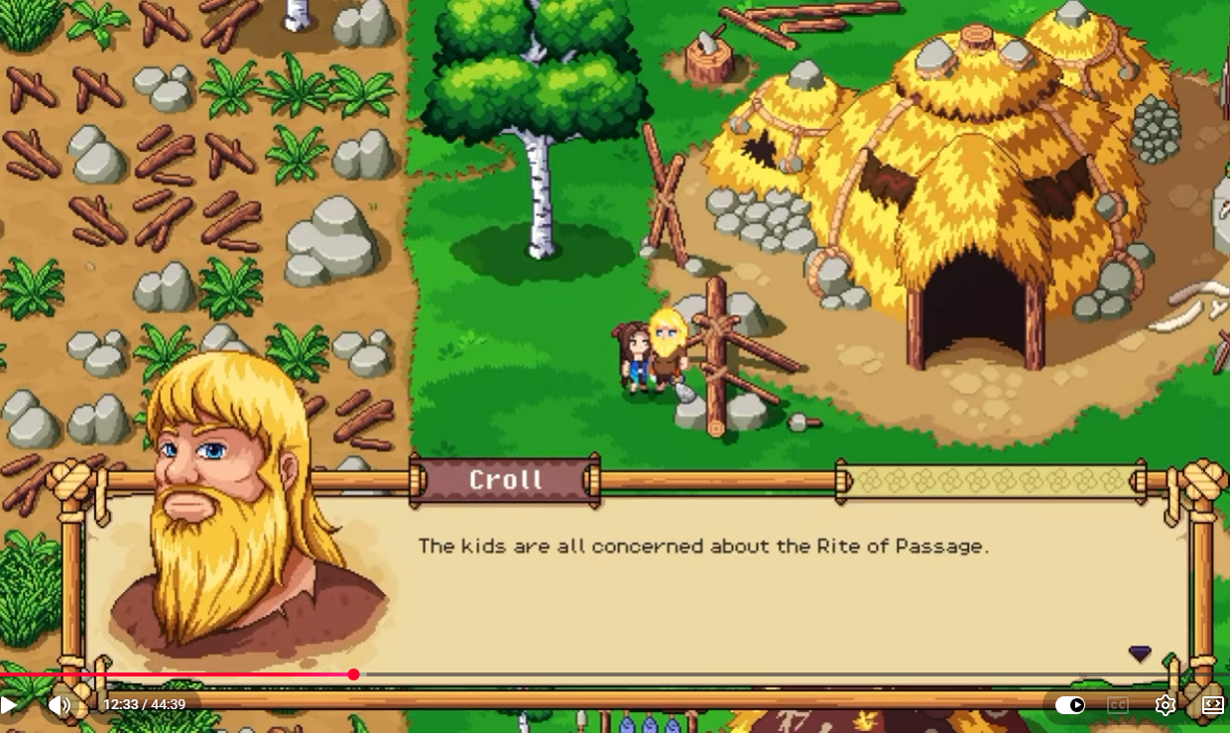
So for the dialogue coming up, what we should do is have the whole window used for the dialogue coming from the NPC that we're talking to, with that little arrow at the bottom right.

While you're in this reading phase, we don't show any options or space for options; basically, the text will fill up this entire page.

Then, as you're finishing the dialogue, the window should smoothly, cutely, and I guess "tween" into the state that has the response options below it (it shouldn't snap up). These options should be nice and small down the bottom.

We will also have our option to scroll up through the text again, but this mode only gets switched to when you've read all of that NPC's dialogue.
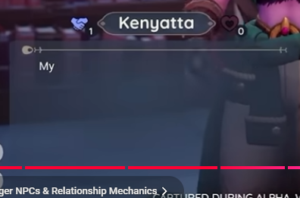
We’re also thinking about ways to improve the NPC relationship feedback.
I think a good way to do it won’t just be writing "trust" and having a bar. Instead, we could actually have a little button or a circular icon (since we now have an icon set) that indicates the trust level we have for that NPC.

